# Recorded Steps

This file contains all the steps and information that was recorded to help you describe the steps in using the project

# The project was created for BFSI Sector to file GST return 3B through system for accuracy and speed as the returns are filed for each state separately and Copy pasting is not allowed in GST return filing forms.

# Libraries Used:

# Easygui – for graphical user interface

# Selenium – For web driver automation

# CSV – to import csv data

# PIL – to capture captcha for input and future use in modelling

# Steps

Previous Next

**Step 1: (‎31-‎05-‎2019 12:04:37)** User left double click on "Name (edit)" in "GST Return Automation"

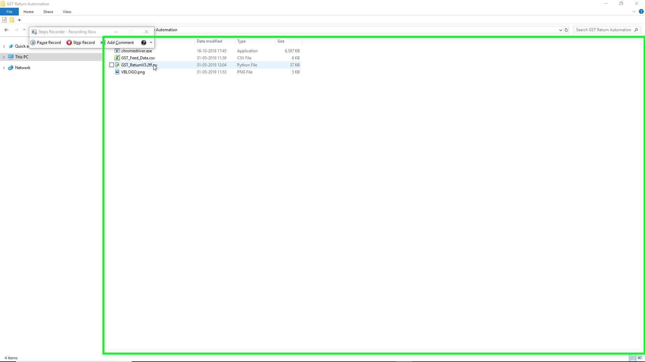Step 1 screenshot.

Previous Next

**Step 2: (‎31-‎05-‎2019 12:04:40)** User left click on " (window)" in " "

To manually enter the User IDs

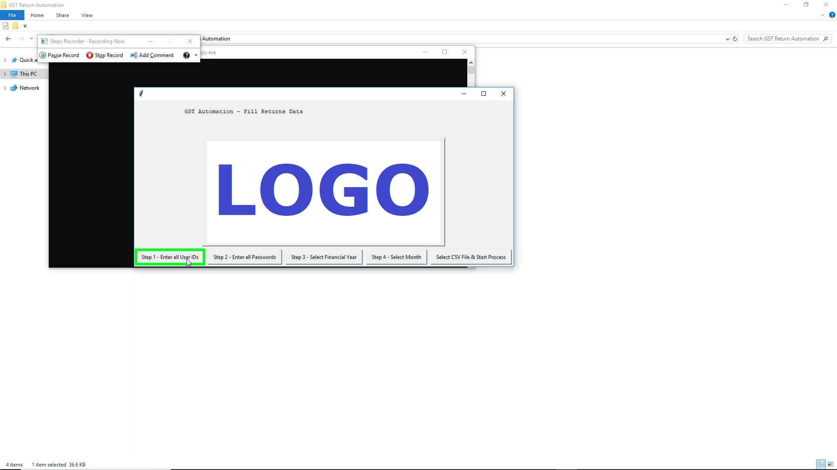Step 2 screenshot.

Previous Next

**Step 3: (‎31-‎05-‎2019 12:04:41)** User left click on " (window)" in " "

To manually enter the User IDs

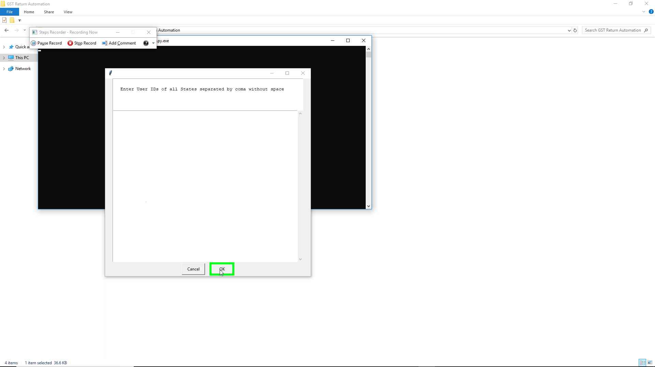Step 3 screenshot.

Previous Next

**Step 4: (‎31-‎05-‎2019 12:04:42)** User left click on " (window)" in " "

To manually enter the corresponding Passwords

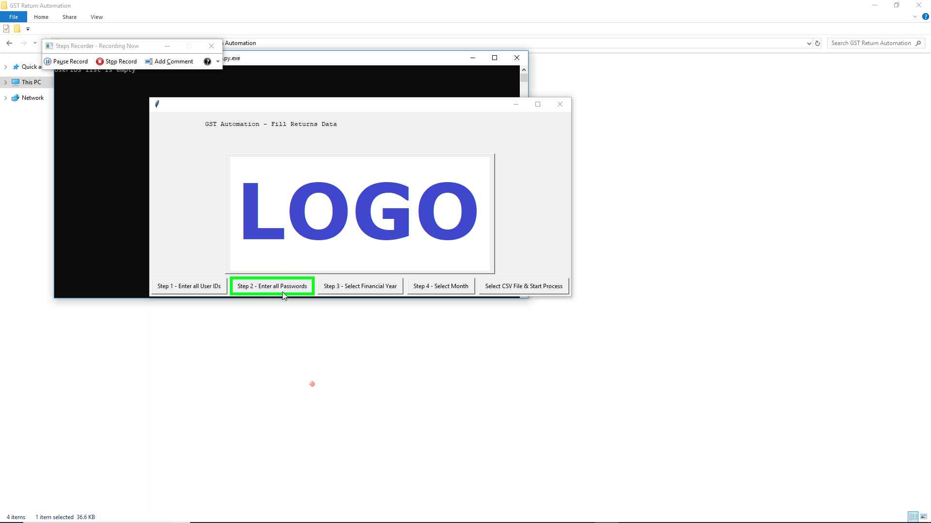Step 4 screenshot.

Previous Next

**Step 5: (‎31-‎05-‎2019 12:04:43)** User left click on " (window)" in " "

To manually enter the corresponding Passwords

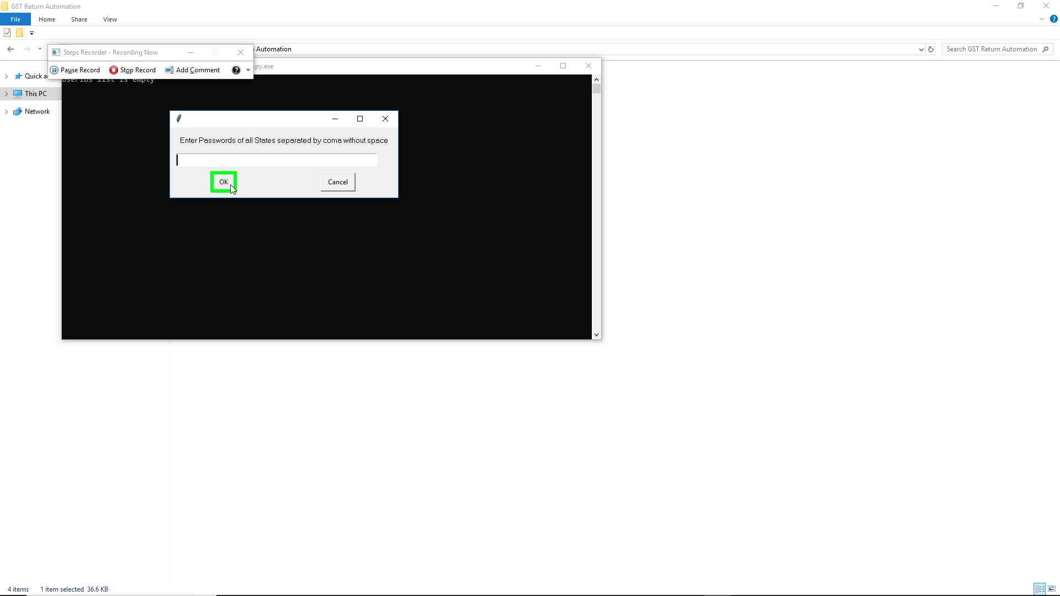Step 5 screenshot.

Previous Next

**Step 6: (‎31-‎05-‎2019 12:04:44)** User left click on " (window)" in " "

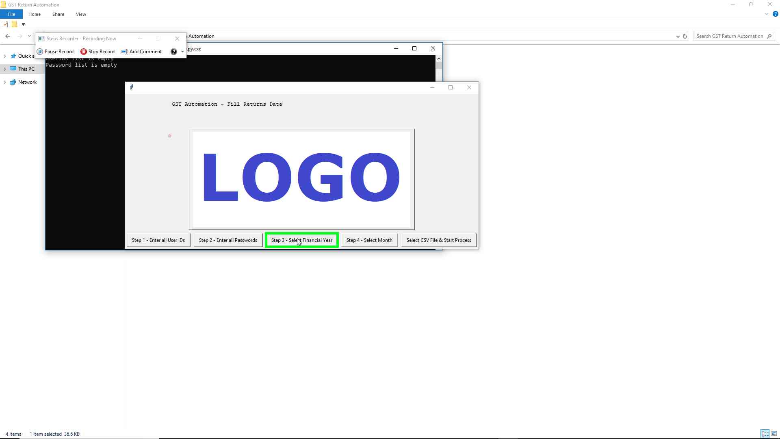Step 6 screenshot.

Previous Next

**Step 7: (‎31-‎05-‎2019 12:04:45)** User left click on "Financial Years (window)" in "Financial Years"

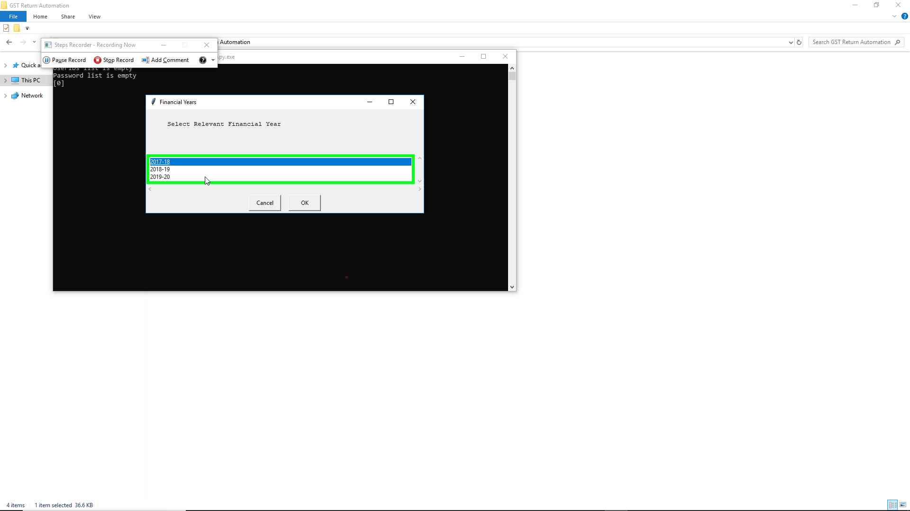Step 7 screenshot.

Previous Next

**Step 8: (‎31-‎05-‎2019 12:04:45)** User left click on "Financial Years (window)" in "Financial Years"

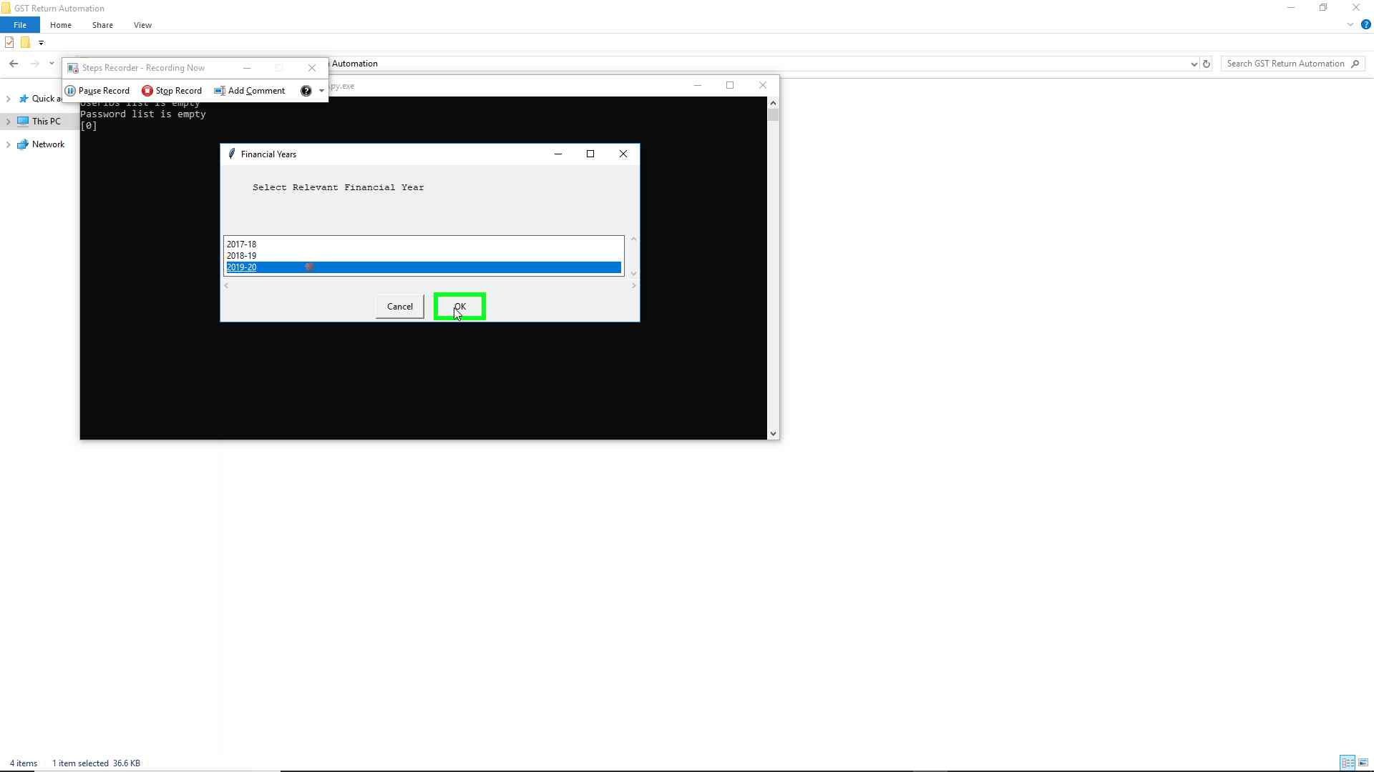Step 8 screenshot.

Previous Next

**Step 9: (‎31-‎05-‎2019 12:04:46)** User left click on " (window)" in " "

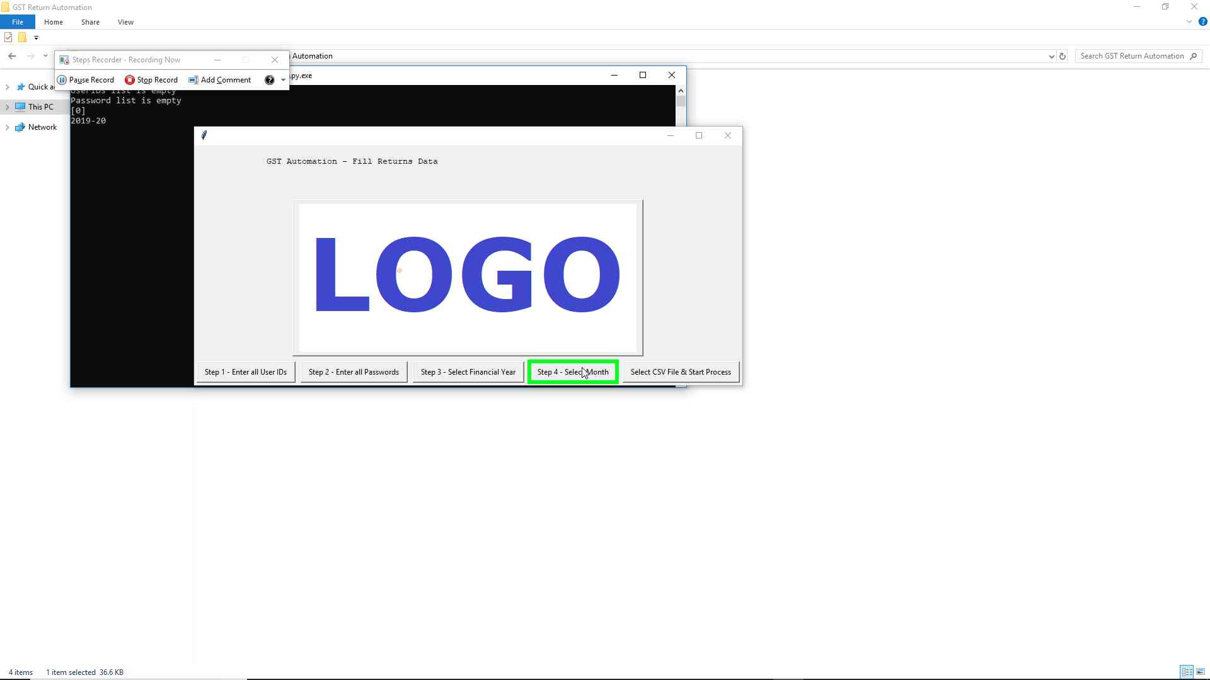Step 9 screenshot.

Previous Next

**Step 10: (‎31-‎05-‎2019 12:04:48)** User left click on "Month (window)" in "Month"

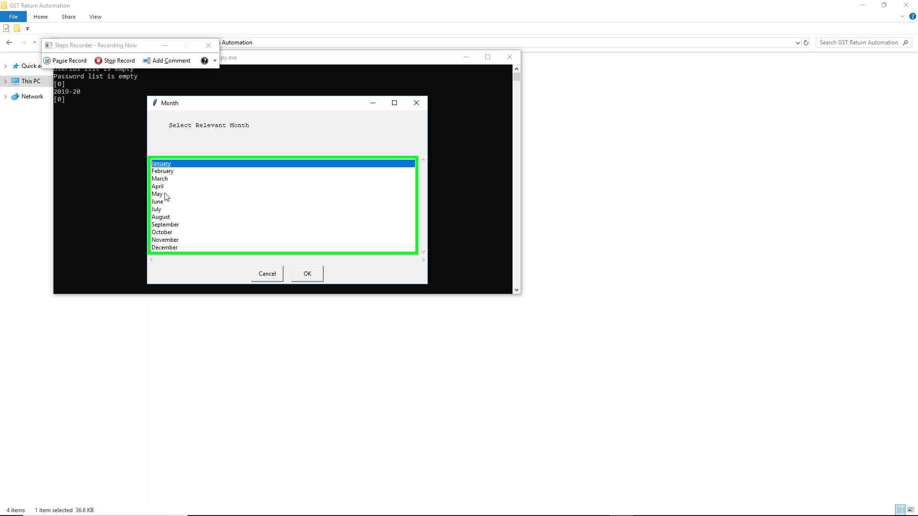Step 10 screenshot.

Previous Next

**Step 11: (‎31-‎05-‎2019 12:04:49)** User left click on "Month (window)" in "Month"

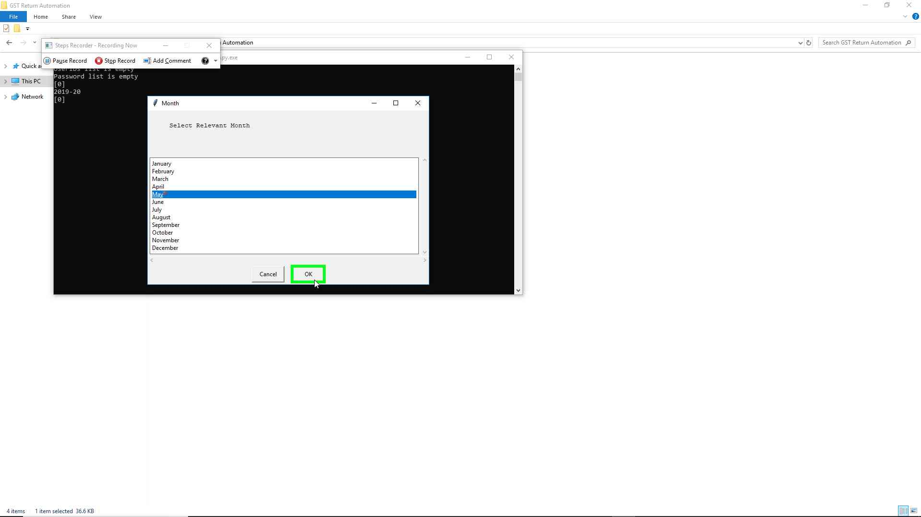Step 11 screenshot.

Previous Next

**Step 12: (‎31-‎05-‎2019 12:04:50)** User left click on " (window)" in " "

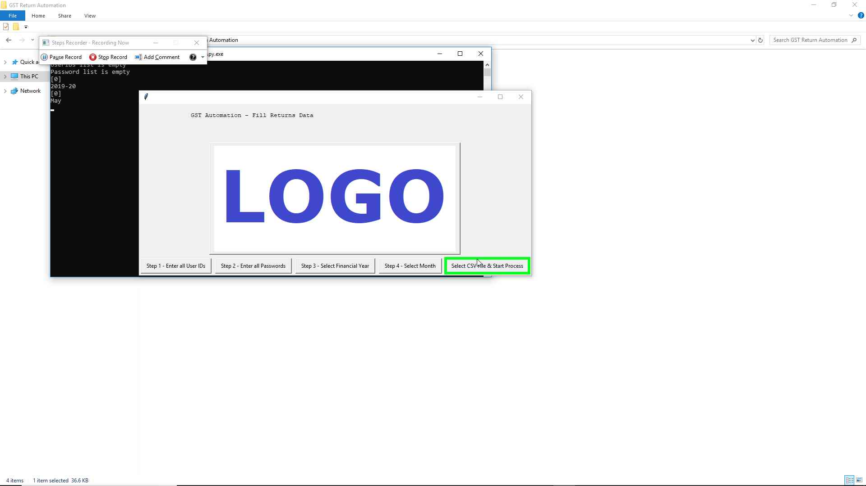Step 12 screenshot.

Previous Next

**Step 13: (‎31-‎05-‎2019 12:04:52)** User left double click on "Name (edit)" in "GSTR3B Login & Return Filing Data - select csv file format"

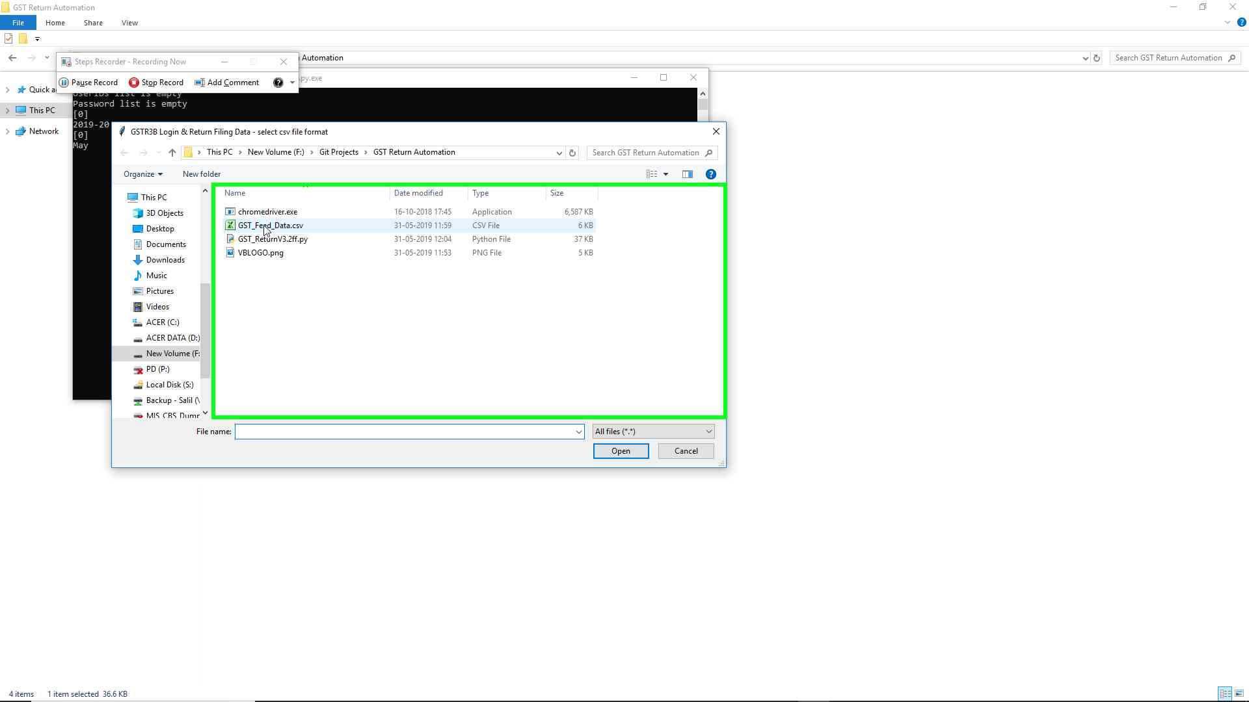Step 13 screenshot.

Previous Next

**Step 14: (‎31-‎05-‎2019 12:04:54)** User left click on "Step 5 - Start Process (window)" in "Step 5 - Start Process"

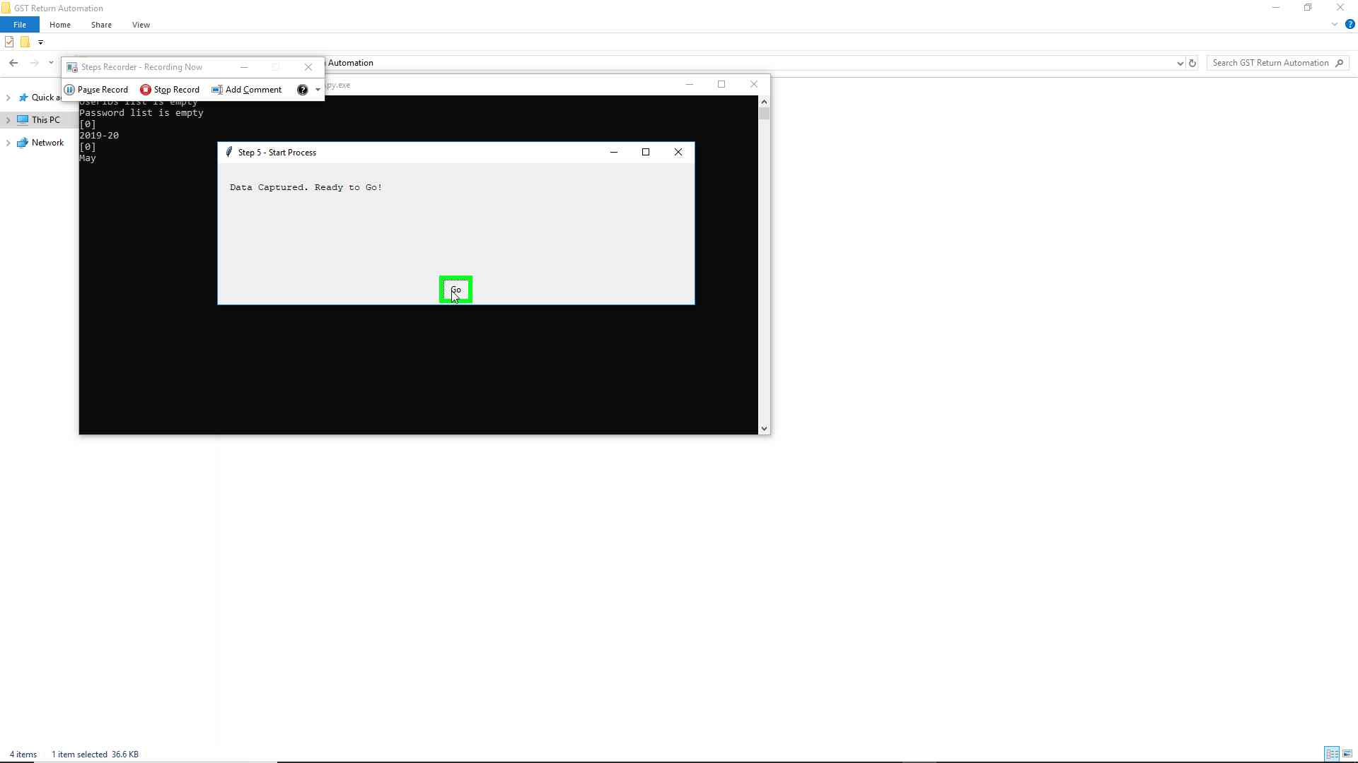Step 14 screenshot.

Previous Next

**Step 15: (‎31-‎05-‎2019 12:05:06)** User keyboard input on " (window)" in " " [... Enter]

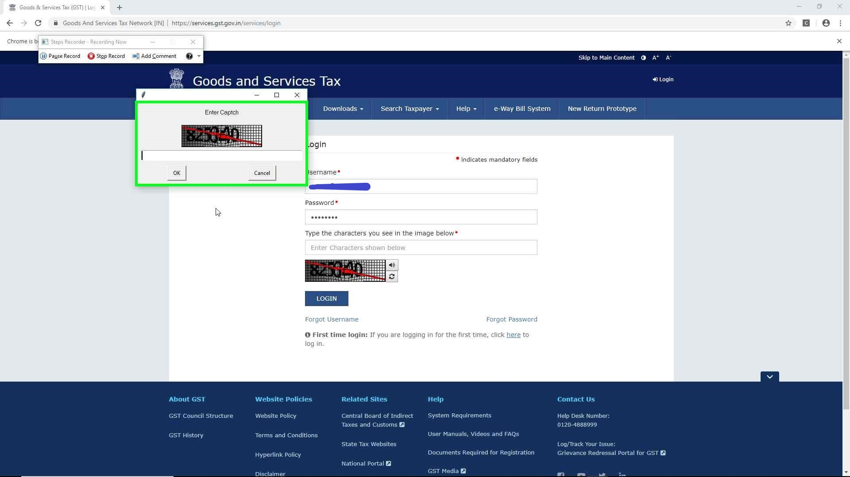Step 15 screenshot.

**All the other steps and data input is done automatically by the program. After completion of 1st return in CSV file, the program will sign out and close the window to open new window to file next return.**

Following screenshots shows the buttons and data fields clicked and fed by the program:

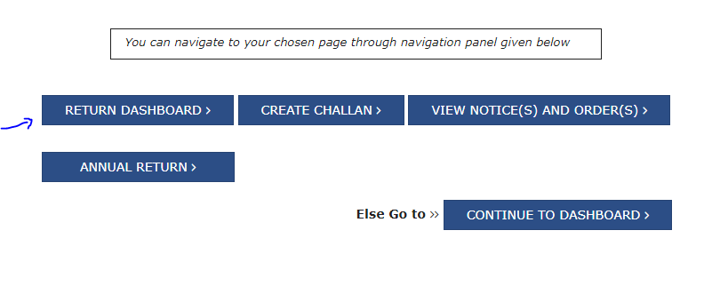

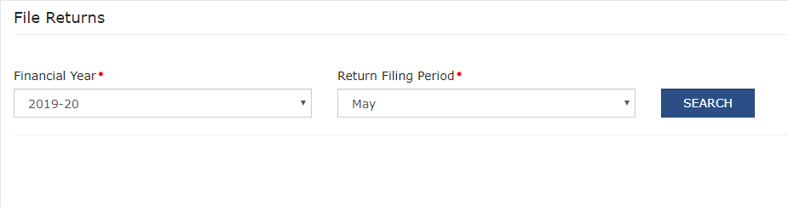

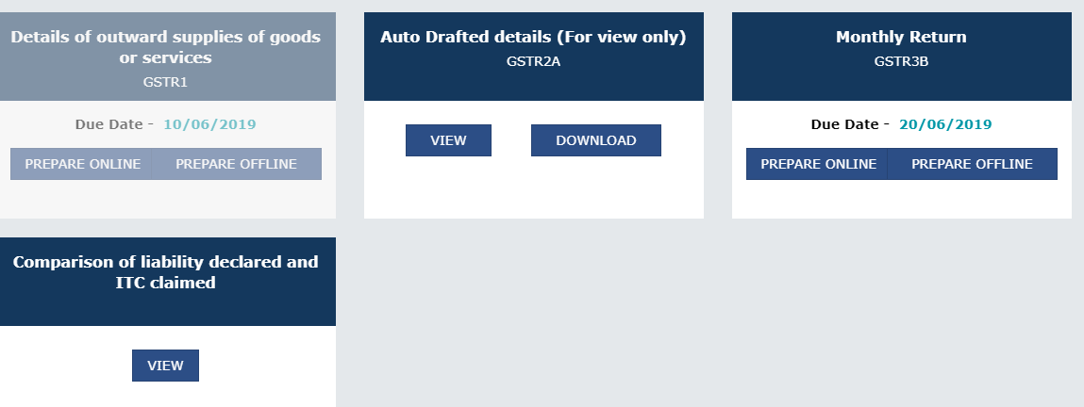

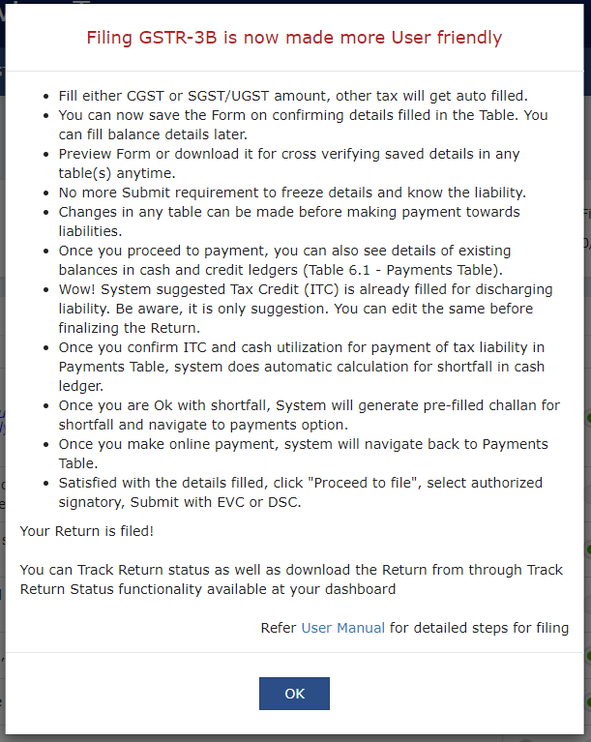

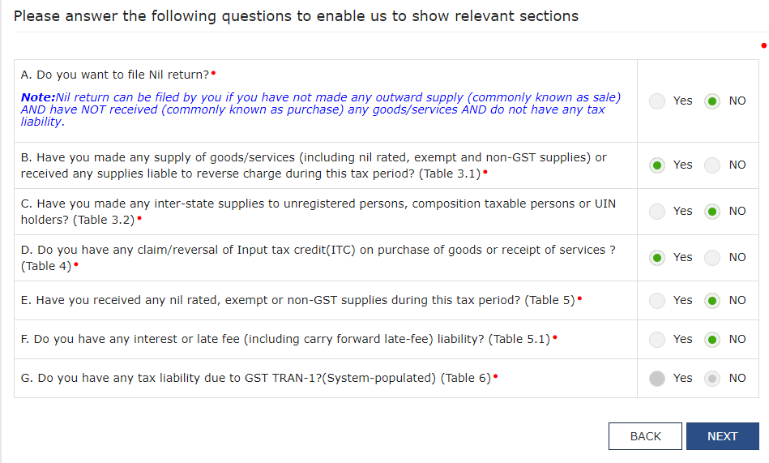

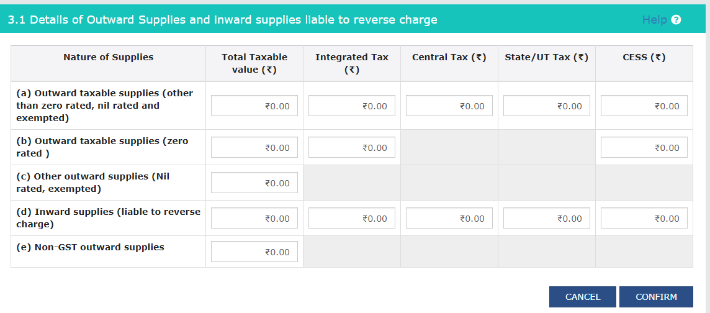

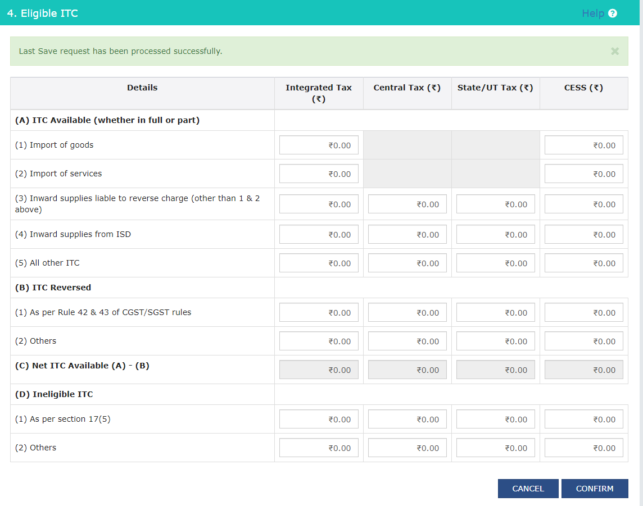

Return to top of page...